**Lab 5: Retrieving Data from the Database**

**1. Retrieve All Products:**

// 1. Retrieve All Products

var products = await context.Products.ToListAsync();

foreach (var p in products)

    Console.WriteLine($"{p.Name} - ₹{p.Price}");

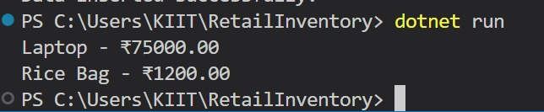

**2. Find by ID:**

// 2. Find by ID

var product = await context.Products.FindAsync(1);

Console.WriteLine($"Found: {product?.Name}");

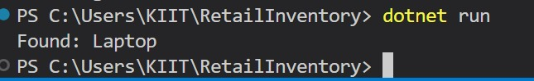

**3. FirstOrDefault with Condition:**

// 3. FirstOrDefault with Condition

var expensive = await context.Products.FirstOrDefaultAsync(p => p.Price > 50000);

Console.WriteLine($"Expensive: {expensive?.Name}");

